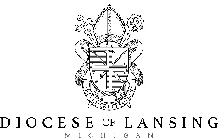  Joseph  Smith  St. Mary Cathedral, Lansing  Rite of Election |  | Joseph  Smith  St. Mary Cathedral, Lansing  Rite of Election
Joseph  Smith  St. Mary Cathedral, Lansing  Rite of Election |  | Joseph  Smith  St. Mary Cathedral, Lansing  Rite of Election
Joseph  Smith  St. Mary Cathedral, Lansing  Rite of Election |  | Joseph  Smith  St. Mary Cathedral, Lansing  Rite of Election
Joseph  Smith  St. Mary Cathedral, Lansing  Rite of Election |  | Joseph  Smith  St. Mary Cathedral, Lansing  Rite of Election

