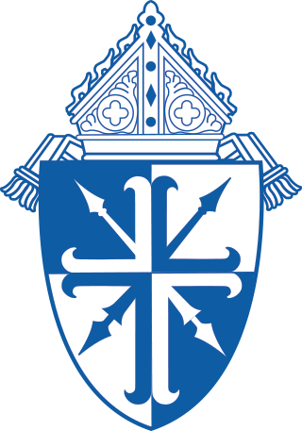
Diocese of Lansing
Catechist Formation Program
Online Courses

Information about our program can be found on the DioceseofLansing.org.
www.DioceseofLansing.org > “Parish Religious Education” page > “Catechist Formation” page

How to Enroll as an Individual on the Catechetical Institute of Franciscan University

Step One: Visit www.franciscanathome.com/lansing

You will see this at the bottom of the page. Choose the second blue box with the silhouette of a person.

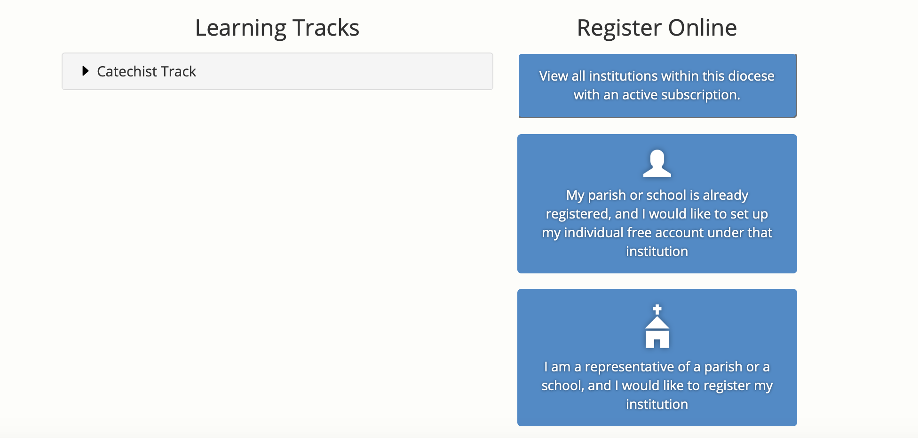

Step Two: Click “create a new account”

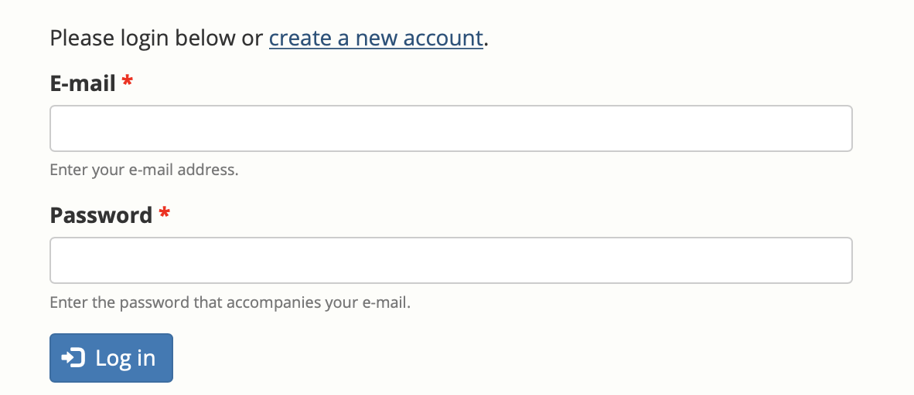

Step Three: Fill in Account information
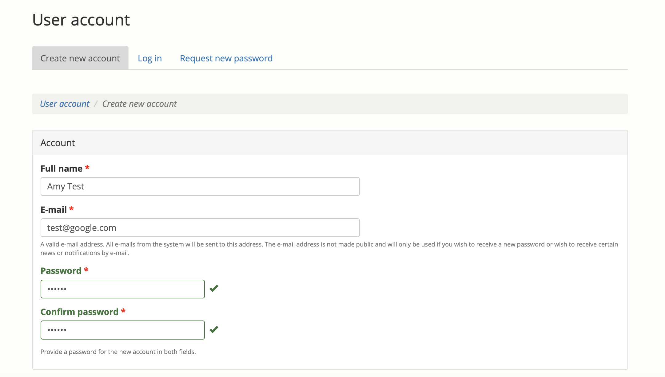

Step Four: At the bottom of that page Click “Create new account” to save your information
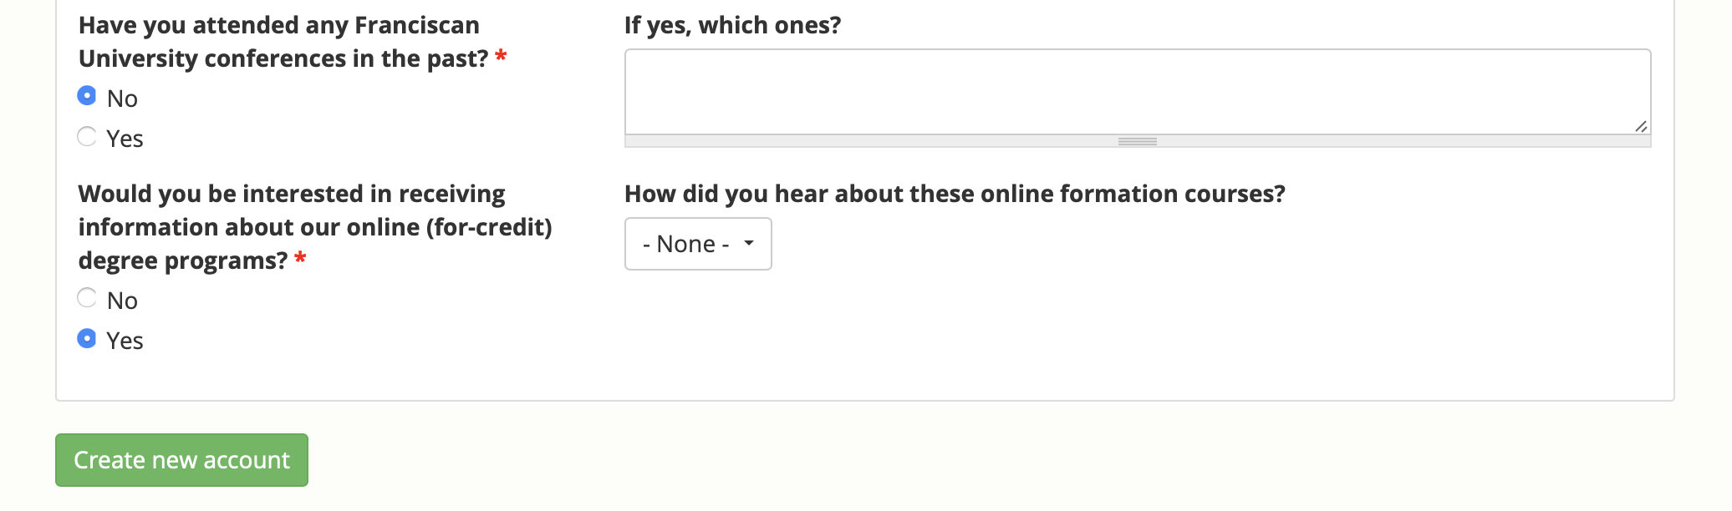

Step Five: Select “Diocese of Lansing” as the diocese
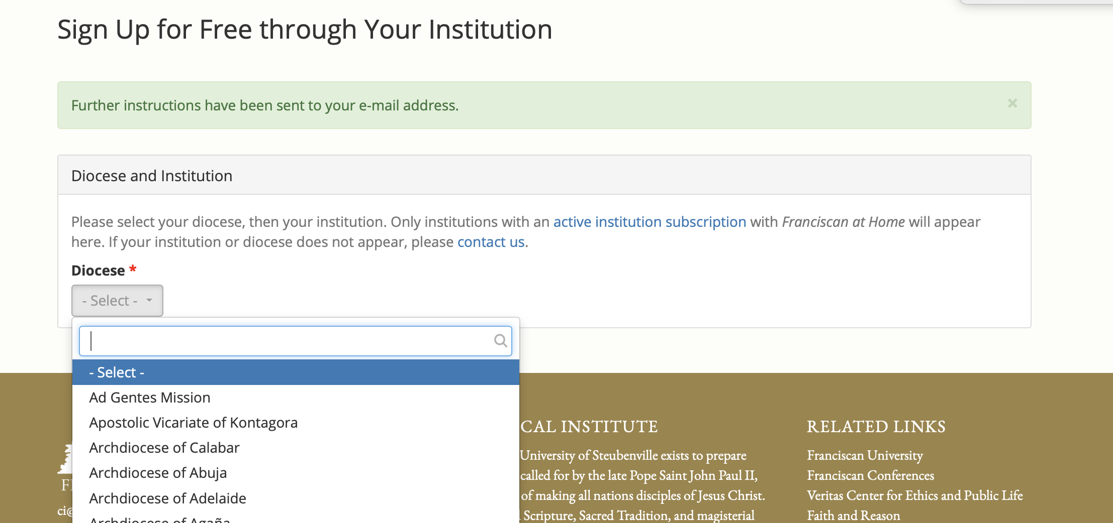

Step Six: Select your institution from the drop down list

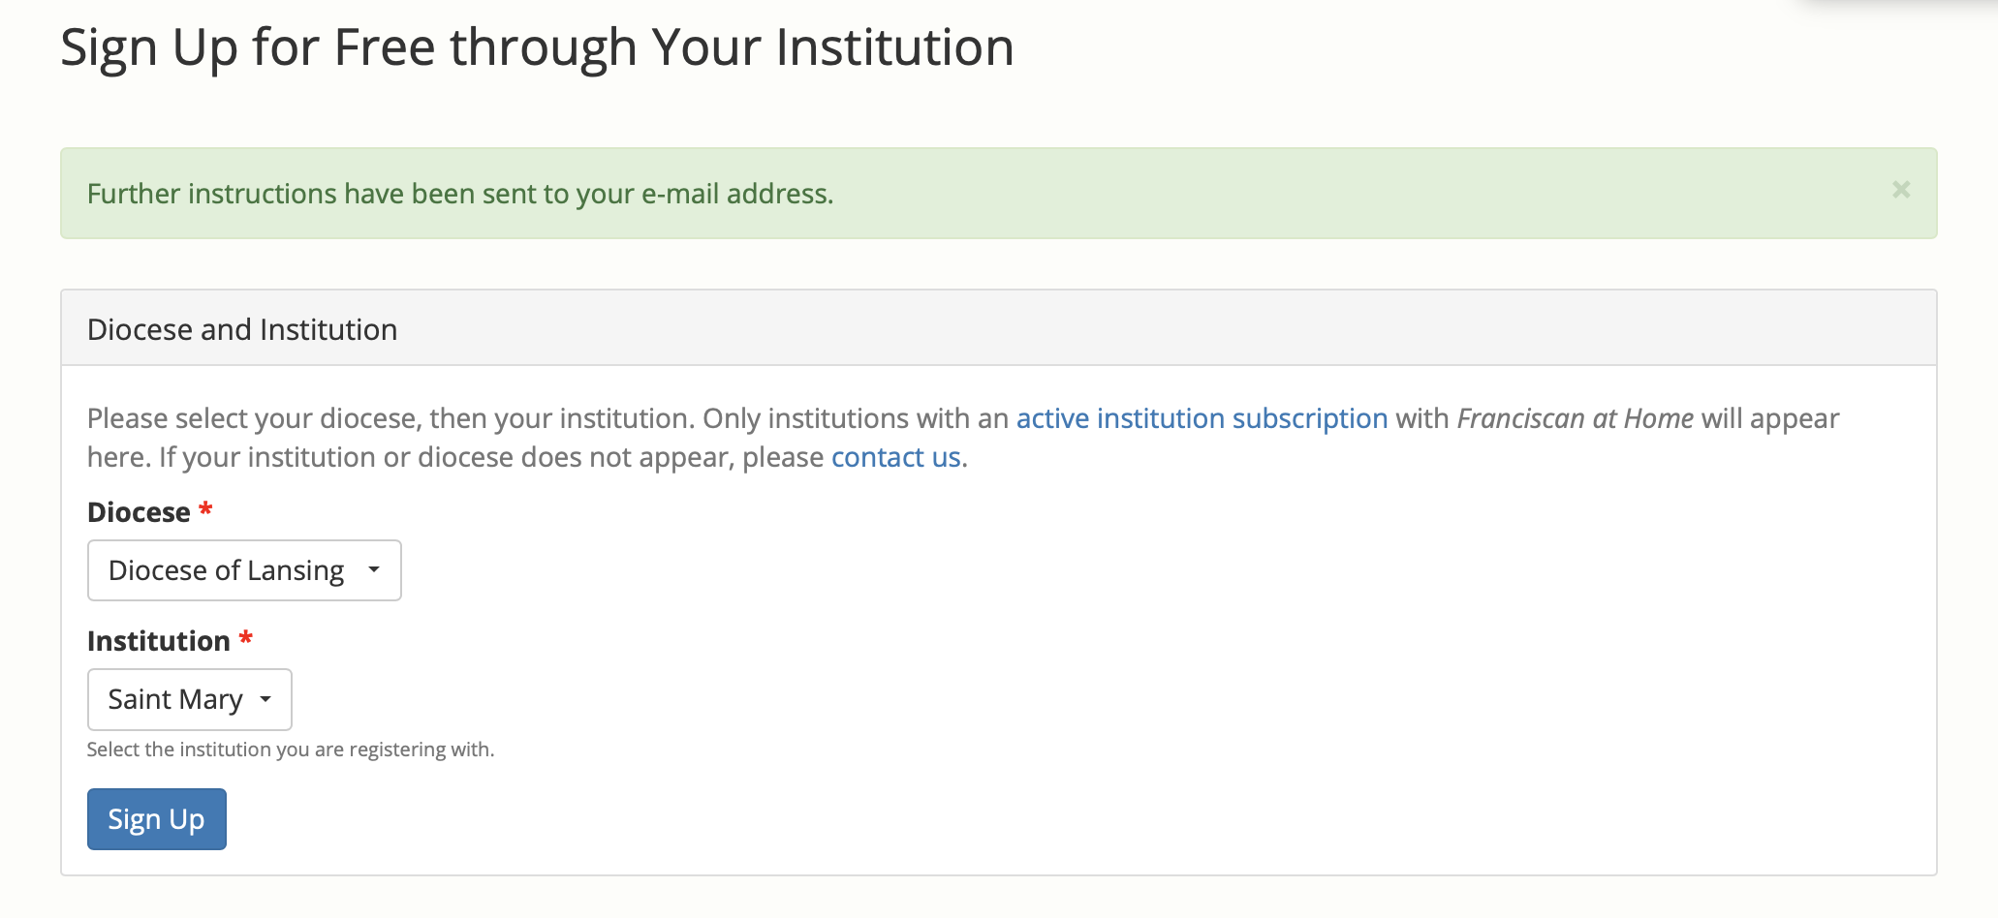

Step Seven: Click on the Catechist Track Under the Diocese of Lansing in the Institution Tracks. This is where you will access the coursework for the Diocese of Lansing.

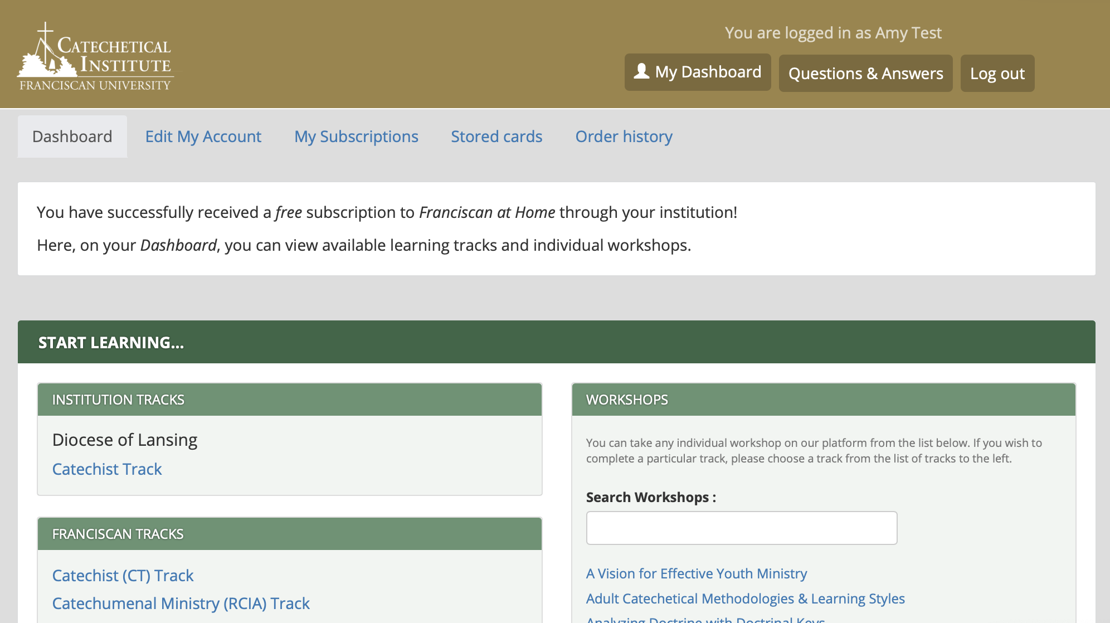

Step Eight: Click “Start this track and request a mentor from Diocese of Lansing”

